Topic: Measurement | EQ: How do we measure the world around us?
Questions  Length  Mass/weight  Capacity  Temperature | Notes:  To measure length, we can use;  Ruler, measuring tape, trundle wheel,  To measure mass/weight we can use  Scales  To measure capacity, we can use;  Measuring jugs and cups/  We measure temperature in degrees Celsius and we use a thermometer

WORKSHEET
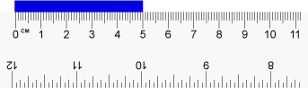  How long is the blue bar? | 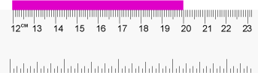  How long is the pink bar?
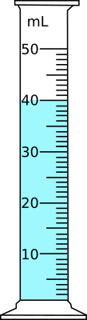  How much water is in this measuring cylinder? | 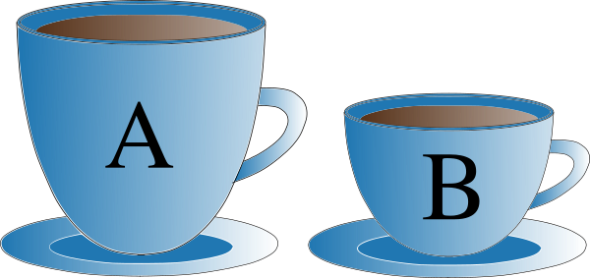  If tea cup A has a capacity of 500mL, estimate the capacity of tea cup B.
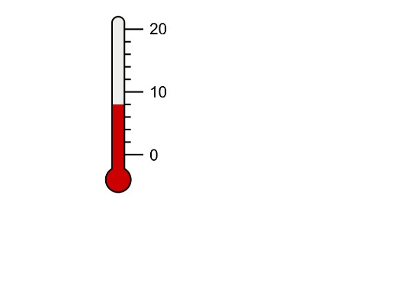  What temperature is on the thermometer? | 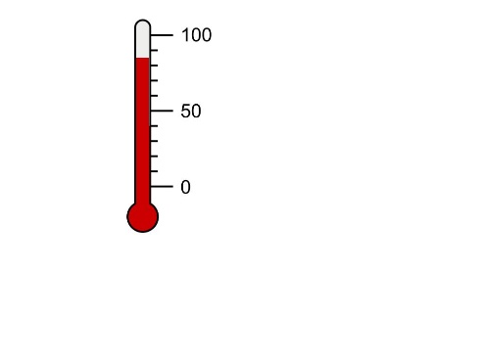  What temperature is on the thermometer?
Consider the following scales.
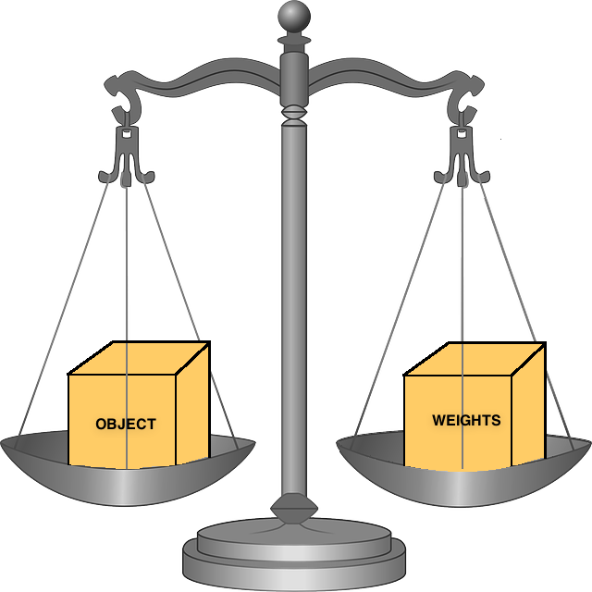

How much does the object weigh if the following weights are on the scale? | 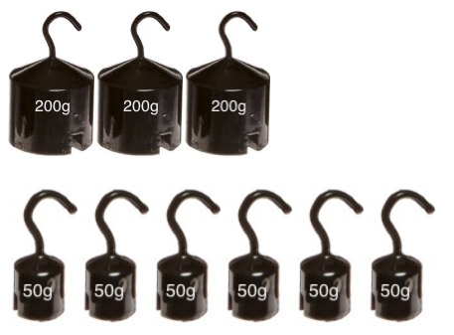
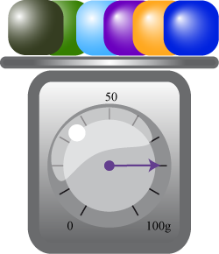  What is the measurement on the scale? | 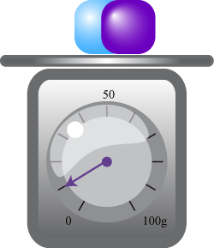  What is the measurement on the scale?

